### **MVP Submission :**

**Project: SmartWaste – AI-Powered Food Waste Reduction System**

**MVP Overview:** This MVP demonstrates the core functionalities of SmartWaste, aimed at reducing food waste through AI-driven inventory management and expiry prediction.

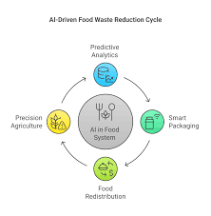

**Features Included in MVP:**

* **Food Item Recognition:** Users can scan or upload images of food items, which are automatically identified using AI image recognition.
* **Expiry Date Prediction:** The system predicts the estimated expiry date based on item type, purchase date, and historical data.
* **Notification System:** Users receive timely reminders to use or consume food before it expires.
* **Recipe Suggestions:** Based on available ingredients, the MVP suggests recipes to help utilize food efficiently.
* **Dashboard:** Basic interface for users to view their food inventory, expiry status, and waste analytics.

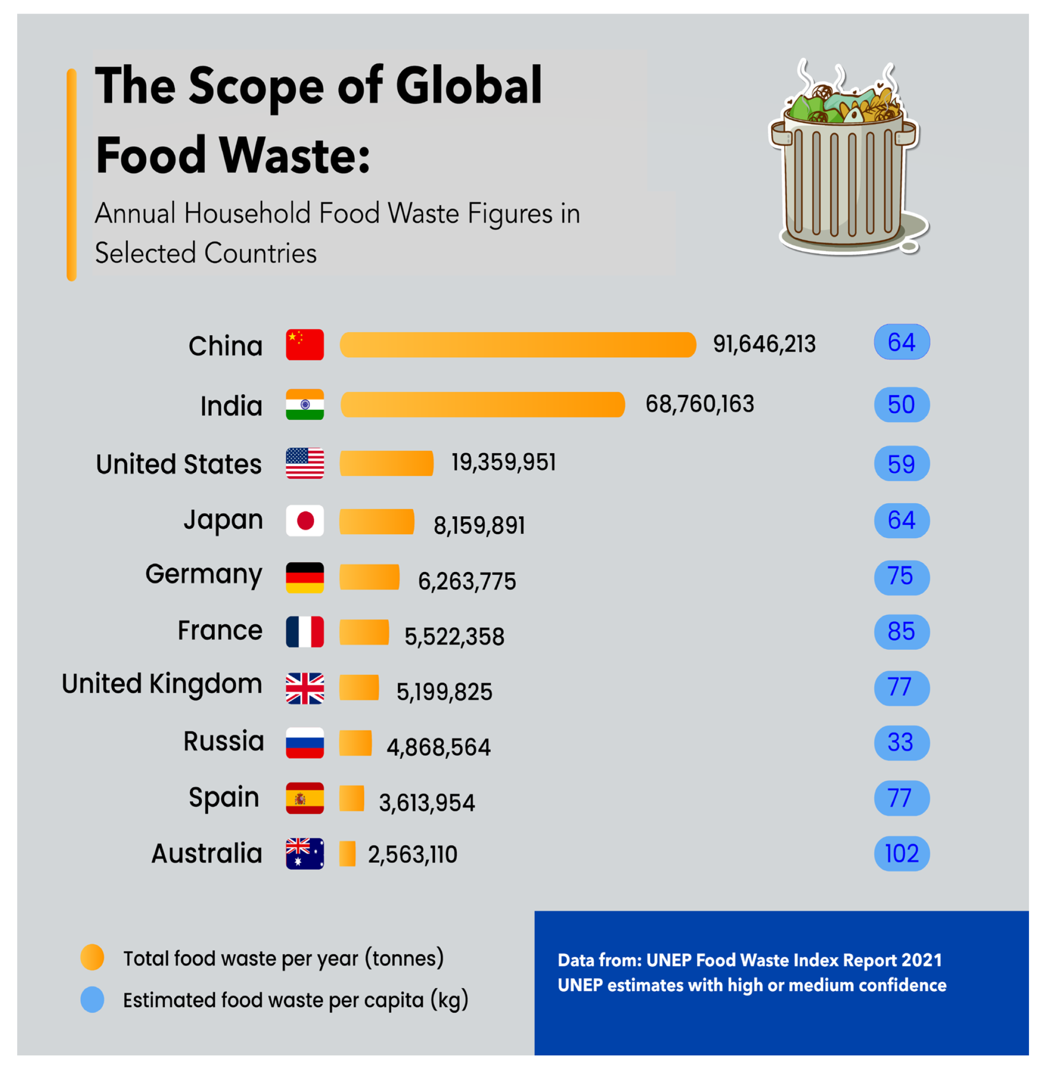

**Technology Used:**

* Frontend: React.js
* Backend: Python Flask
* AI/ML: TensorFlow (image recognition), Scikit-learn (expiry prediction)
* Database: PostgreSQL
* Hosting: Google Cloud Platform
* 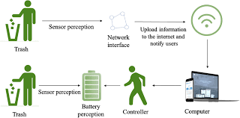

**Instructions to Use MVP:**

* Access the web app via the demo link: [Insert demo URL here]
* Login with provided test credentials (if any)
* Use the camera or upload image feature to add food items
* View expiry notifications and explore recipe suggestions

**Known Limitations:**

* Limited database of food items in current version
* Basic UI/UX, with further improvements planned
* Notifications are currently manual reminders in the demo

### **Roadmap**

* **MVP Development & Internal Testing:** Completed by July 31, 2025
* **Beta Release & User Testing:** August 15 – September 15, 2025
* **Gather User Feedback & Implement Enhancements:** September 20 – October 15, 2025
* **Marketing Campaign & Partnership Outreach:** October 20 – November 30, 2025
* **Official Product Launch:** December 15, 2025
* **Post-Launch Support & Scaling:** January 2026 onwards
* **Future Updates:** AI-driven shopping list optimization, smart kitchen device integration, multi-language support

**Competitive Analysis**

* **Current Solutions:** Apps like ‘FoodKeeper,’ ‘Too Good To Go,’ and smart fridge systems
* **Limitations of Competitors:** Limited AI capabilities, poor integration, lack of personalized notifications
* **SmartWaste Advantages:**
  + Advanced AI image recognition for automatic food identification
  + Predictive expiry alerts using machine learning
  + Recipe suggestions tailored to user inventory
  + Comprehensive analytics dashboard for waste tracking
  + Cross-platform accessibility (mobile + web)
* **Potential Challenges:** User adoption, data privacy concerns, scaling AI accuracy
* **Mitigation Strategies:** User education, transparent data policies, continuous AI model training

### **Impact & Future Vision**

* **Environmental Impact:** Reduce food waste by up to 30% among users, significantly lowering methane emissions
* **Economic Impact:** Save users hundreds of dollars annually on groceries
* **Social Impact:** Promote sustainable habits and responsible consumption
* **Community Building:** User challenges and rewards for waste reduction
* **Long-Term Vision:**
  + Integration with IoT smart kitchen devices and grocery stores
  + Collaboration with local governments for community waste programs
  + Expansion into other perishable goods (medicines, cosmetics)
  + Use AI for personalized nutrition and health recommendations